Lab-1

Introduction to Python

1. Installing Python on Windows

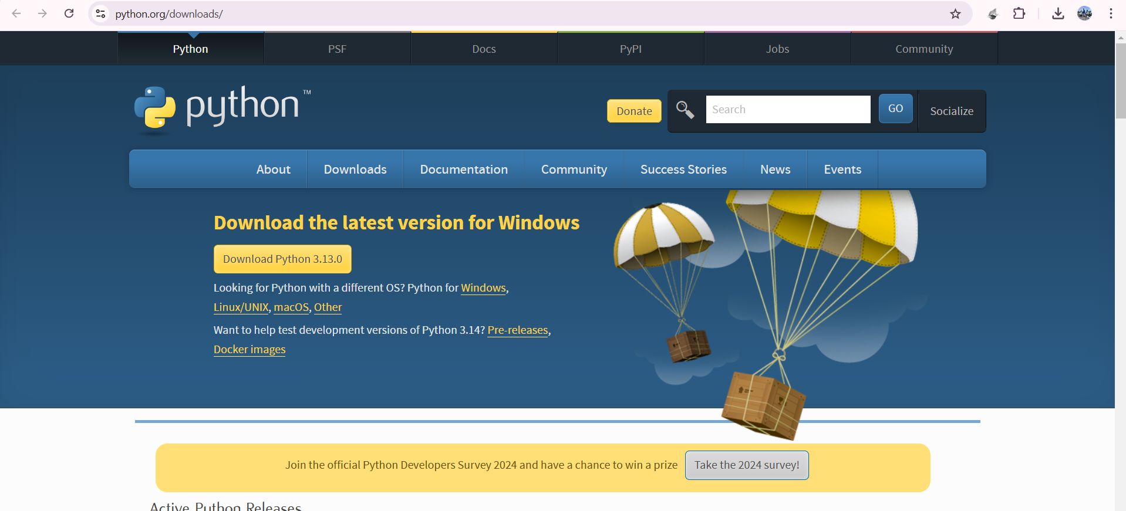

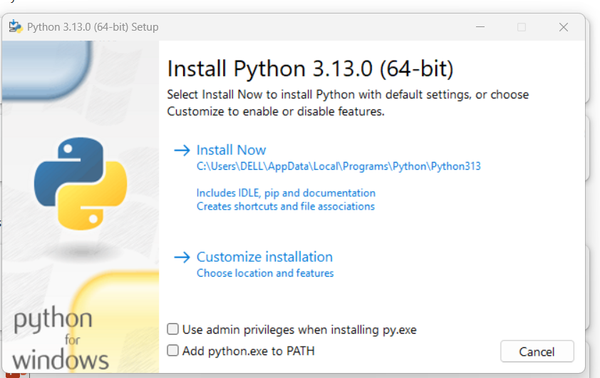

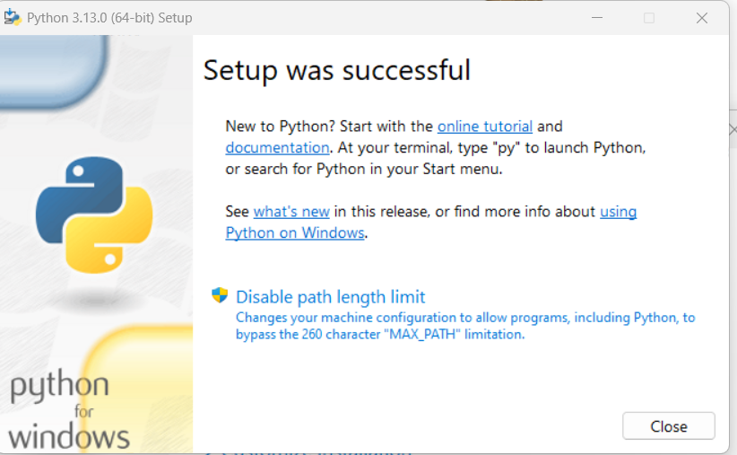

2. Demonstrate about Basics of Python Programming:

i. Running Python Interpreter:

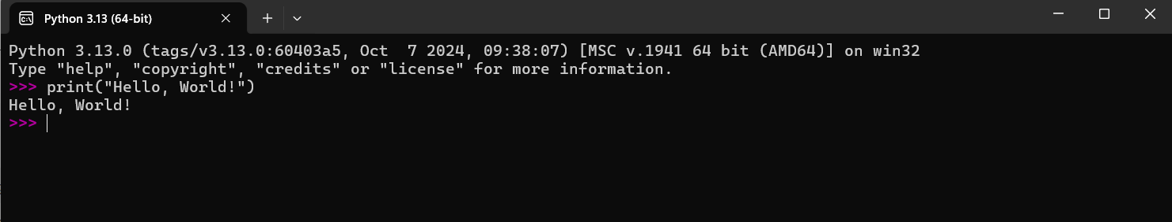

ii. Running Python Scripts in IDLE (Integrated Development and Learning Environment):

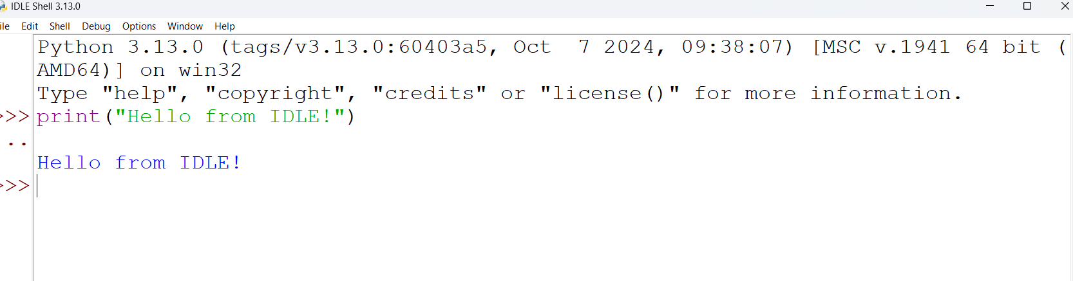

iii. Indentation.

